**Project Report**

JOP APPLICATION TRACKING SYSTEM

**1 INTRODUCTION**

* 1. **Overview**

Every organization is unique, but each one thrives on attracting, hiring, and maximizing top talent. Many businesses face major challenges at some point in the hiring or onboarding process. An [ATS can offer a variety of capabilities](https://blogs.oracle.com/oraclehcm/post/why-you-should-use-an-applicant-tracking-system) that can help the organization find, hire, and retain the best candidates. Some of the benefits of an ATS include the following.

* 1. **Purpose**

An ATS creates opportunities to automate manual processes, increase visibility into the hiring cycle for the entire recruiting team, and increase opportunities for communication throughout the candidate journey. 78% of recruiters using an ATS report that it has improved the quality of the candidates they hire.

1. **Problem Definition & Design Thinking**
   1. **Empathy Map**

* 1. **Ideation & Brainstorming Map**

**3 RESULT**

**3.1 Data Model:**

|  |  |  |
| --- | --- | --- |
| **Object name** | **Fields in the Object** | |
| **Obj1** | |  |  | | --- | --- | | Field lable | Data type | | Recruiter | |  |  | | --- | --- | |  | Auto Number | | | |
| **Obj2** | | |  |  | | --- | --- | | Field lable | Data type | | Candidate | |  |  | | --- | --- | |  | Text | | |

**3.2 Activity & Screenshot**

**Milestone 1- Salesforce:**

**Activity1:**

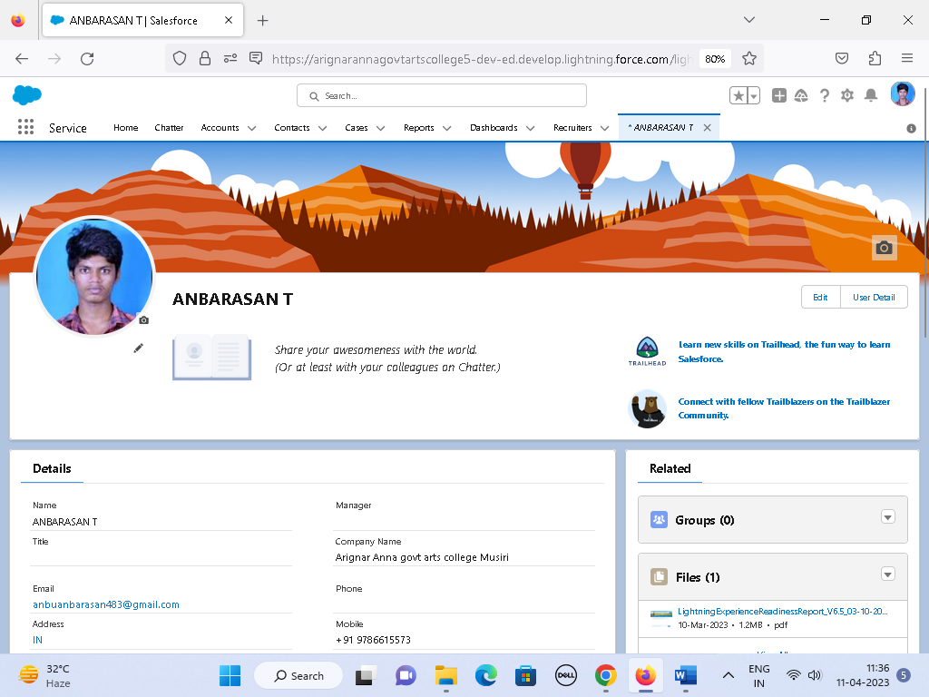

**Milestone 2 - Object:**

**Activity1:**

**Activity 2:**

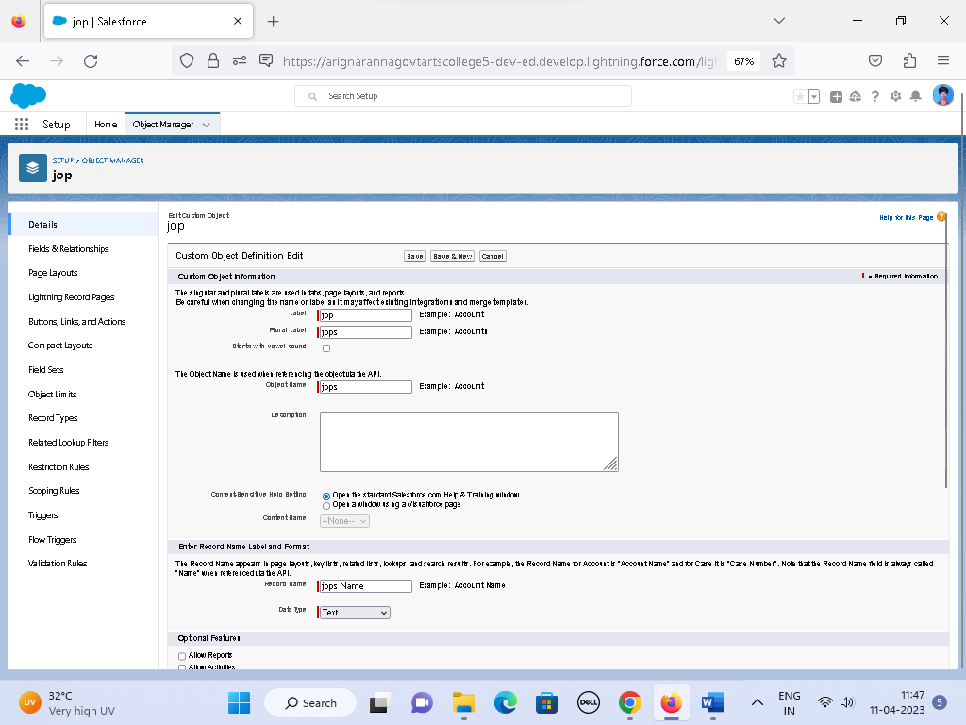

**Milestone 3- Fields:**

**Activity 1:**

**Activity 2:**

**

**Activity 4:**

**Milestone 4-Tab:**

**Activity 1 :**

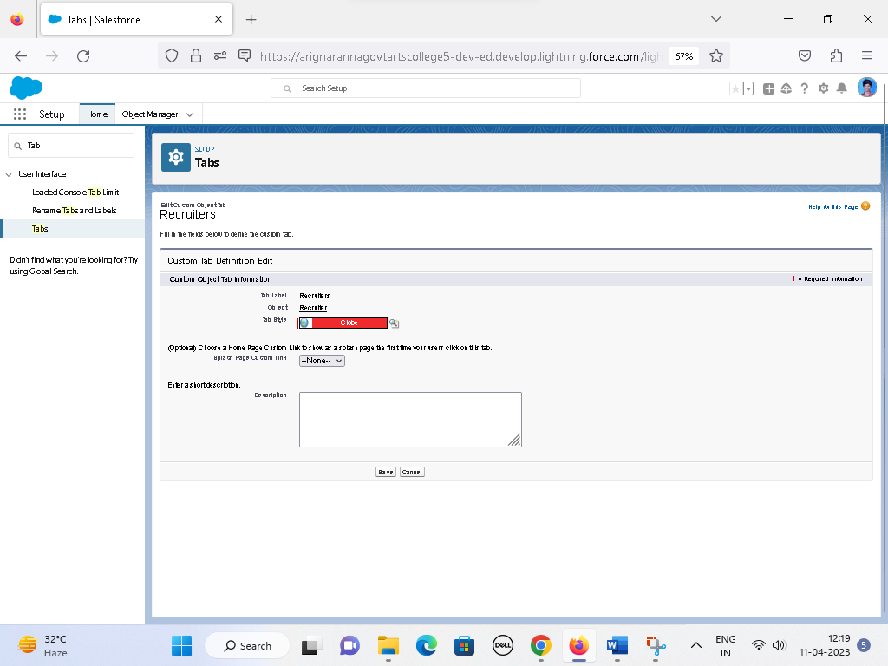

**Milestone 5- Profile:**

**Activity 1:**

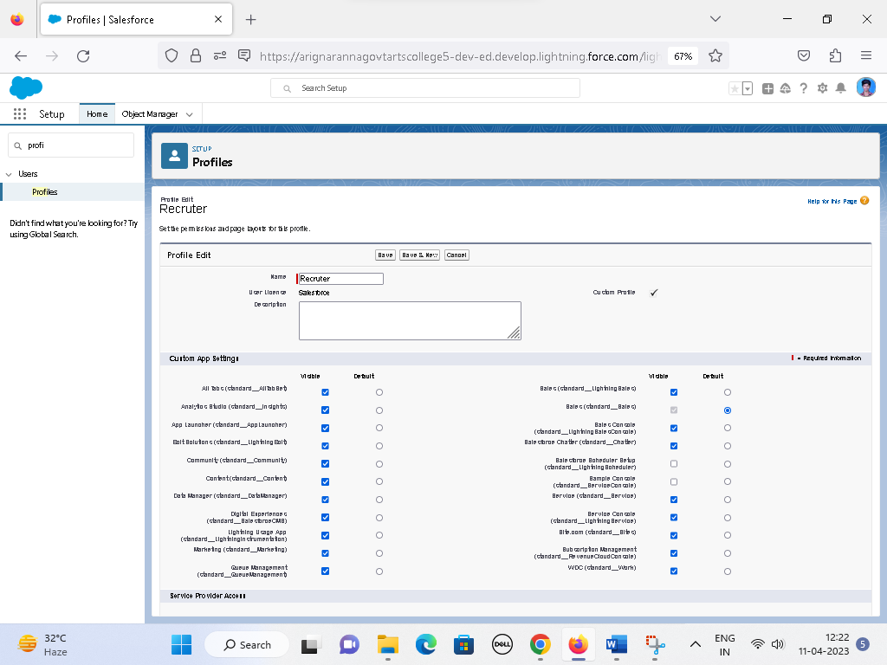

**Activity 2:**

**Milestone 6-User**

**Activity 1:**

**Activity 2:**

**Milestone 7-Sharing Rules**

**Activity 1:**

**Activity 2:**

**Milestone 8-Reports:**

**

**Activity 2:**

# Trailhead Profile Public URL

**Team Lead - https://trailblazer.me/id/anbu143**

**Team Member 1 –https://trailblazer.me/id/kbabyphy**

Team Member 2 –https://trailblazer.me/id/bpavi18

Team Member 3 – APSENT

1. **ADVANTAGES & DISADVANTAGE**
2. **ADVANTAGES**

* [The Biggest Applicant Tracking System Advantage is Streamlined Hiring Process](https://www.naukrirms.com/blog/applicant-tracking-system-pros-and-cons-you-should-keep-in-mind/" \l "The-Biggest-Applicant-Tracking-System-Advantage-is-Streamlined-Hiring -Process).
* [Improved Quality of Hire is another advantage of ATS](https://www.naukrirms.com/blog/applicant-tracking-system-pros-and-cons-you-should-keep-in-mind/" \l "Improved-Quality-of-Hire-is-another-advantage-of-ATS).
* [Better Candidate Experience is one of the top benefits of Applicant Tracking System](https://www.naukrirms.com/blog/applicant-tracking-system-pros-and-cons-you-should-keep-in-mind/" \l "Better-Candidate-Experience-is-one-of-the-top-benefits-of-Applicant-Tracking-System).
* [Strong employer brand is another advantage of an ATS](https://www.naukrirms.com/blog/applicant-tracking-system-pros-and-cons-you-should-keep-in-mind/" \l "Strong-employer-brand-is-another-advantage-of-an-ATS).
* [Collaborative hiring is another benefit of Applicant Tracking Software](https://www.naukrirms.com/blog/applicant-tracking-system-pros-and-cons-you-should-keep-in-mind/" \l "Collaborative-hiring-is-another-benefit-of-Applicant-Tracking-Software).

1. **DISADVANTAGE**

* [A Disadvantage of ATS is missing qualified applicants due to wrong keyword selection](https://www.naukrirms.com/blog/applicant-tracking-system-pros-and-cons-you-should-keep-in-mind/" \l "A-Disadvantage-of-ATS-is-missing-qualified-applicants-due-to-wrong-keyword-selection).
* [Automatic elimination of resumes that software cannot recognize and interpret is another drawback of ATS](https://www.naukrirms.com/blog/applicant-tracking-system-pros-and-cons-you-should-keep-in-mind/" \l "Automatic-elimination-of-resumes-that-software-cannot-recognize-and-interpret-is-another-drawback-of-ATS).
* [An Applicant Tracking System Disadvantage is that they are open to manipulation](https://www.naukrirms.com/blog/applicant-tracking-system-pros-and-cons-you-should-keep-in-mind/" \l "An-Applicant-Tracking-System-Disadvantage-is-that-they-are-open-to-manipulation).

# APPLICATIONS

* Create stronger job descriptions.
* Extend recruiter reach and reduce friction.
* Automate and increase efficiency.
* Improve visibility and collaboration across recruiting teams.

# CONCLUSION

Applicant Tracking System for recruiters is a very effective hiring solution that most of the successful recruiters utilize. Because without it, there is a good chance that your process of moving applicants through different stages can become very difficult. This tool is very important for optimizing the hiring process with the help of [artificial intelligence and technology](https://www.peoplehum.com/blog/the-role-of-artificial-intelligence-in-the-hiring-process). As we move forward, the ATS tools are evolving and making the monotonous tasks easy.

# FUTURE SCOPE

Applicant tracking system (ATS) is software that simplifies the recruiting process by organising candidates with automated intelligence. This helps the recruiters screen the most and best-qualified candidates based on collected information regarding experience, skillset, and other aspects.Applicant tracking systems have a vast market, with more than [**90% of Fortune 500 companies**](https://medium.com/swlh/90-of-fortune-500-companies-use-an-applicant-tracking-system-whats-it-5a6b6d25e5e7) using the software. It was valued at 2.3 billion US dollars in 2025 and will be approximately 3.2 billion US dollars in the next five years.

# 